# **JAYPEE INSTITUTE OF INFORMATION TECHNOLOGY, SECTOR 62**

# 

**MINOR PROJECT REPORT**

# **Project:- Wireless Weather Monitoring System**

**Submitted to:**

**Prof. Kirmender Singh**

**Department of Electronics and Communication Engineering**

**Submitted By:**

**Chetan Jain, 16802003**

Project Report Contents

|  |
| --- |
| Abstract |
| Introduction |
| Equipments |
| Application |
| Current Status of Development |
| Future Development |
| Vision and Marketing Strategy |
| References |

Abstract

Weather monitoring plays an important role in human life, so the collection of information about the temporal dynamics of weather changes is very important. In any industry during certain hazards it is very important to monitor weather.

The fundamental aim of this paper is to develop an embedded system to design a wireless weather monitoring system which enables the monitoring of weather parameters in an industry. Such a system contains sensor like temperature and humidity will be monitored and DHT22 operated on NODE MCU ESP 8266.

The data from the sensors are collected by NODE MCU and also sends the sensors data in to the WeatherCheck Website by using the Internet connection provided by Router provided and the data sent by module will be in discreet and kept in google sheets & also we can get live update of other users data through website. The system has an internally installed Real Time Clock programmed to upload data every 15 seconds. Users can also enjoy the facility of a heat Map Updating with each upload in from respective devices.

Introduction

Climate conditions play vital role in our day-to-day life in many areas Such as agricultural sector to industrial sector etc. Weather monitoring station is a device that collects data related to different climates behavior such as temperature, humidity, atmospheric pressure, light intensity, rainfall, wind speed and wind direction using many different sensors.

It can also be described as Automatic Weather Station (AWS). AWS has been widely applied in various fields such as environmental research for geo-statistical, analysis of temperature measurement , prediction of wind energy potential location , measurement of the movement of the mass balance , and estimation of crop water needs .

But in this case It is redefined as an instrument or device, which provides us with the information of the **weather**(temperature and humidity, not rain as there can be high humidity even when temperature is high and not raining at all)  in our neighbouring environment. With help of temperature and humidity we can calculate other data parameters(dew point).

The problem driving me to select project on wireless weather monitoring system is that most of developed existing systems are designed to sense limited number of weather parameters restricting the system to an exact application and reducing its functionality.This module serves as a data logger to upload data from a router directly to the website WeatherCheck IP. The weaknesses of this system are the limited user interface and the additional fee. The user must pay the modules purchased separately. Furthermore, users cannot change the default user interface and manually select the required data to be displayed on the website or mobile devices.This research aims to develop a custom information system and UI design for the weather monitoring system. Therefore, it can be managed on a standalone web server and can be developed on a mobile application such as Android.

Equipments

**DHT 22:**

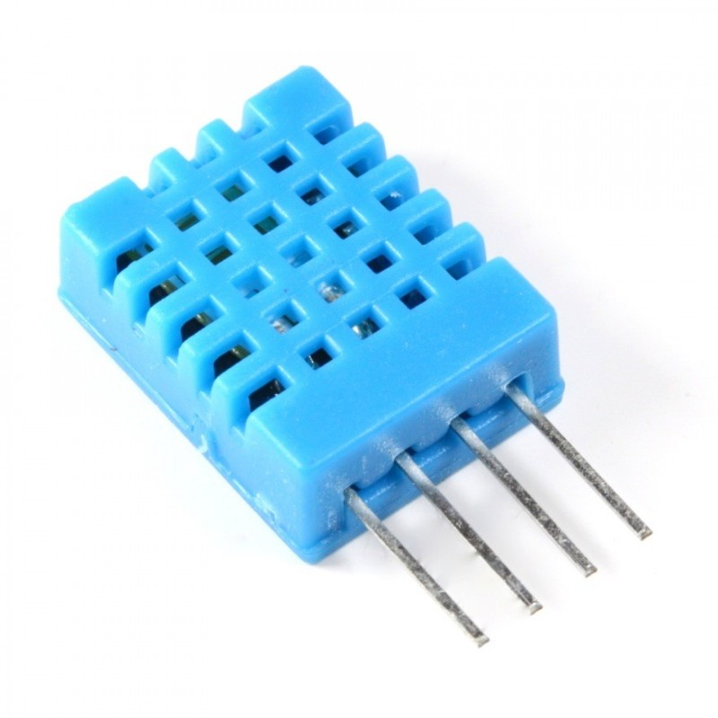

DHT are made of two parts, a capacitive humidity sensor and a thermistor

* Low cost
* 3 to 5V power and I/O
* 2.5mA max current use during conversion (while requesting data)
* Good for 0-100% humidity readings with 2-5% accuracy
* Good for -40 to 80°C temperature readings ±0.5°C accuracy
* No more than 0.5 Hz sampling rate (once every 2 seconds)
* Body size 27mm x 59mm x 13.5mm (1.05" x 2.32" x 0.53")
* 4 pins, 0.1" spacing
* Weight (just the DHT22): 2.4g

They are extremely easy to use, simply connect the first pin on the left to 3-5V power, the second pin to your data input pin and the rightmost pin to ground. Although it uses a single-wire to send data it is not Dallas One Wire compatible! If required multiple sensors, each one must have its own data pin.

**Real Time Clock DS3231:**

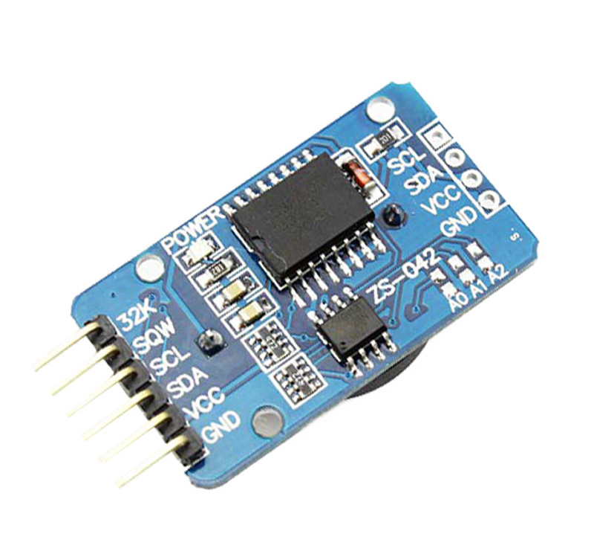

* Highly Accurate RTC Completely Manages All Timekeeping Functions
  + Real-Time Clock Counts Seconds, Minutes, Hours, Date of the Month, Month, Day of the Week, and Year, with Leap-Year Compensation Valid Up to 2100
  + Accuracy ±2ppm from 0°C to +40°C
  + Accuracy ±3.5ppm from -40°C to +85°C
  + Digital Temp Sensor Output: ±3°C Accuracy
  + Two Time-of-Day Alarms
  + Simple Serial Interface Connects to Most Microcontrollers
  + Fast (400kHz) I2C Interface
* Battery-Backup Input for Continuous Timekeeping
  + Low Power Operation Extends Battery-Backup Run Time
  + 3.3V Operation
* Operating Temperature Ranges: Commercial (0°C to +70°C) and Industrial (-40°C to +85°C)

This low-cost, extremely accurate I²C real-time clock (RTC) with an integrated temperature-compensated crystal oscillator (TCXO) and crystal. The battery input maintains accurate timekeeping when main power to the device is interrupted. The integration of the crystal resonator enhances the long-term accuracy of the device as well as reduces the piece-part count in a manufacturing line

**NODE MCU BOARD**

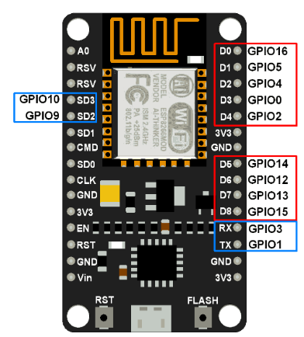

NodeMCU Dev Kit/board consist of ESP8266 wifi enabled chip. The ESP8266 is a low-cost [Wi-Fi](https://en.wikipedia.org/wiki/Wi-Fi) chip with TCP/IP protocol.

ESP 8266 comes with capabilities of:

* 2.4 GHz Wi-Fi (802.11 b/g/n, supporting WPA/WPA2),
* general-purpose input/output (16 GPIO),
* Inter-Integrated Circuit (I²C) serial communication protocol,
* analog-to-digital conversion (10-bit ADC)
* Serial Peripheral Interface (SPI) serial communication protocol,
* I²S (Inter-IC Sound) interfaces with DMA(Direct Memory Access) (sharing pins with GPIO),
* UART (on dedicated pins, plus a transmit-only UART can be enabled on GPIO2), and
* pulse-width modulation (PWM).

**For web part:**

Node.js:- For Backend

Charts.js:- For creating charts of barchart and line chart

Google Maps Api: For heat Map and Google maps markers

HTML5 & CSS3:- for a good UI/UX

Application

There are many other weather apps and other institutes such as news channels but the data or the current weather information we receive from those sources are could be coming from a hundred miles away from an airport or 50 miles away from a government building you never knew. What we want is accuracy. The exact info of temperature in our backyard the exact info of rain in every km of our journey something that even tells us when to open the window because of rainfall or when to go outside in certain park where its sunny.

If a glance out the window—or at a smart-phone notification—tells you all you need to know about the conditions outside, it eliminates the need of wasting time or money digital weatherman for home.

This is all about private use, there are also chances for industrial application such as:

* Many sports and leisure activities depend on weather conditions for optimum enjoyment. This weather stations, with its ability to upload live weather data automatically to a website, allow club members to assess actual weather conditions at the club’s site before making any decision to travel – maybe some distance – to the club.
* It goes without saying that farms, and indeed horticulture on any scale, rely on keeping track of weather conditions to guide many aspects of their work, for example:Crop irrigation;

Monitoring growing conditions to assist with decisions about planting, harvesting etc;

Deciding when to spray to prevent disease;

* Installing a wind turbine or solar panel can be an expensive job with uncertain payback . For instance, the potential for wind power is often overestimated – wind speeds can vary to a surprising extent over relatively short distances and regional averages, which are typically measured at highly exposed sites like airfields, may not be a reliable guide to conditions at local sites. A weather station allows you to monitor real-life local conditions for yourself at the exact position of the proposed site for a period of time and so help to prevent
* Scientific research of many types, eg ecological, archaeological, ageing and weathering of materials outdoors etc is often greatly assisted by a detailed log of weather conditions maintained over the course of a trial or study. Our weather stations can provide a good solution for this sort of application, without undue stress to the research budget. Sometimes, these scientific studies need to be conducted at remote, unattended sites for extended periods and again we can offer tailored solutions for this type of application;uneconomic installations;
* Many commercial and industrial activities are now required either by law or by simple good practice policies to maintain a detailed log of weather conditions at their business sites to help, for example, in: Supporting any weather-related contract disputes;

Managing any potential nuisance from odours and emissions;

Aiding retrospective investigation of any incidents that are alleged to have occurred;

Current Status of Development:-

Currently the weather app designed WeatherCheck has completed a significant amount of work done in much less time with much lesser workforce and resources We have designed a truly beautiful website with elegant design and a simple working type it's easy to create an account with current location. All the user data is stored in Mysql Database and all the user data is encrypted using ‘bcrypt’ package

The circuit looks like this where an RTC is designed to send data asynchronously to WeatherCheck website in every 15 minutes and an ESP currently connected my Mobile Hotspot

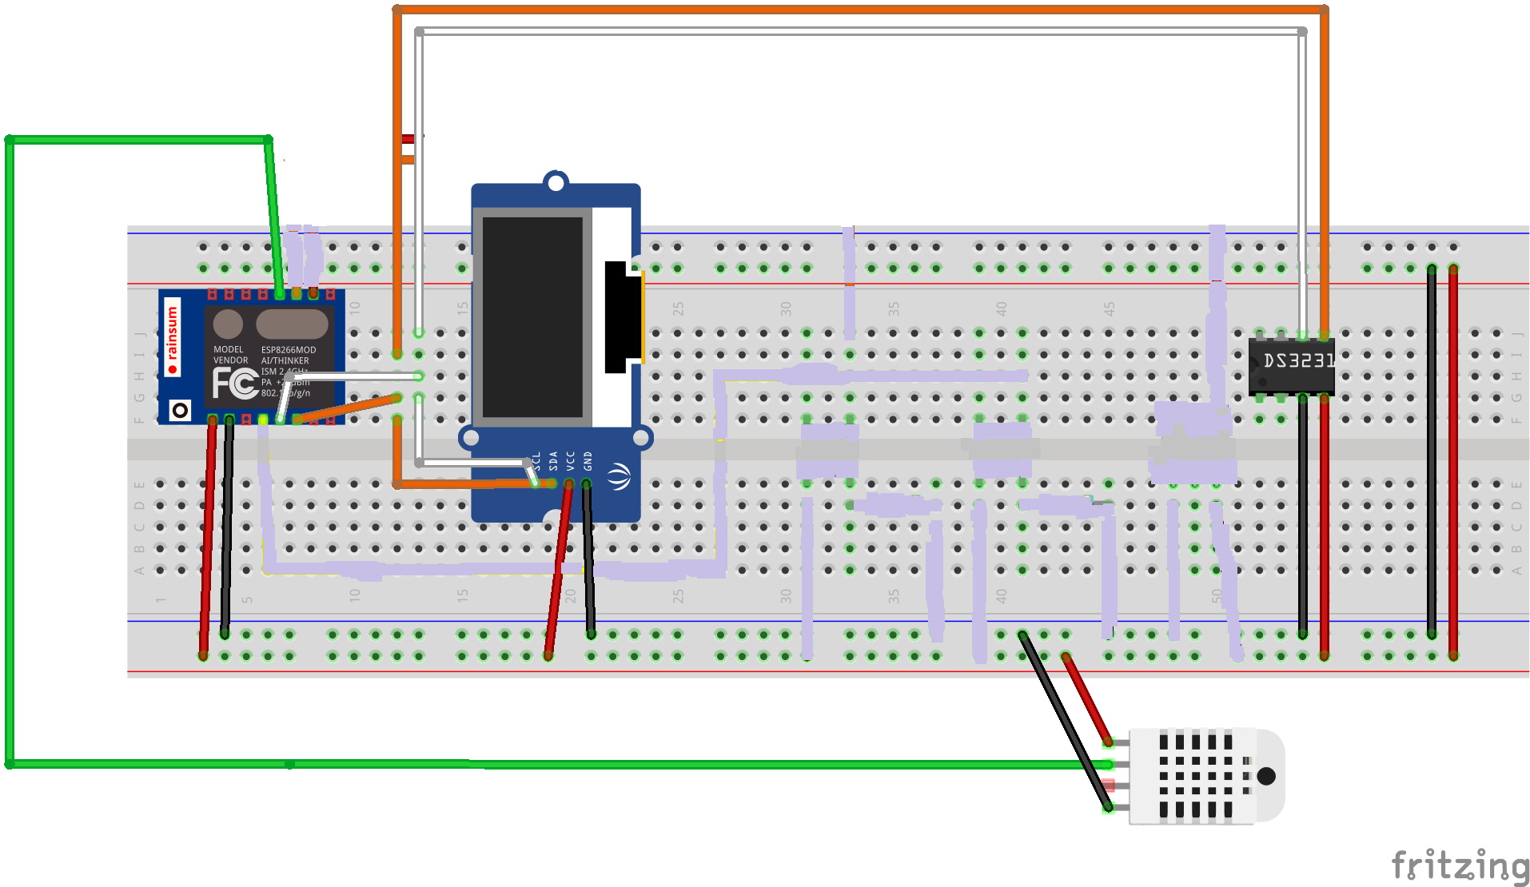

The login page which uses mysql to store userdata and authenticates and created account with the use passport.js looks like this

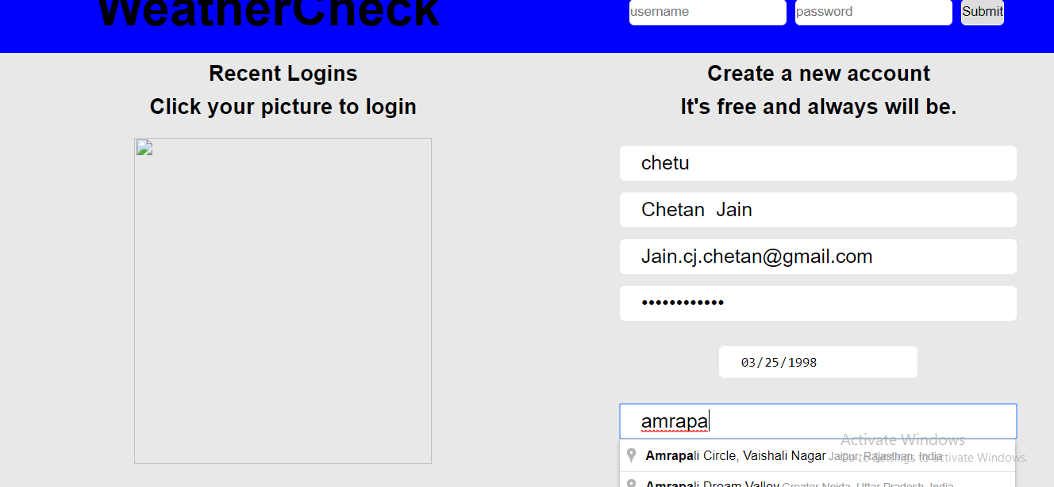

With new developments in the charting of temperature and humidity and a varying heat map with weightage measured in temperature . This is revolutionary app can tell you the places where it is hot and the places where it is safe to go without turning on the ac in your car.

The data generated here is random because of unavailability to generate accurate data without number of users

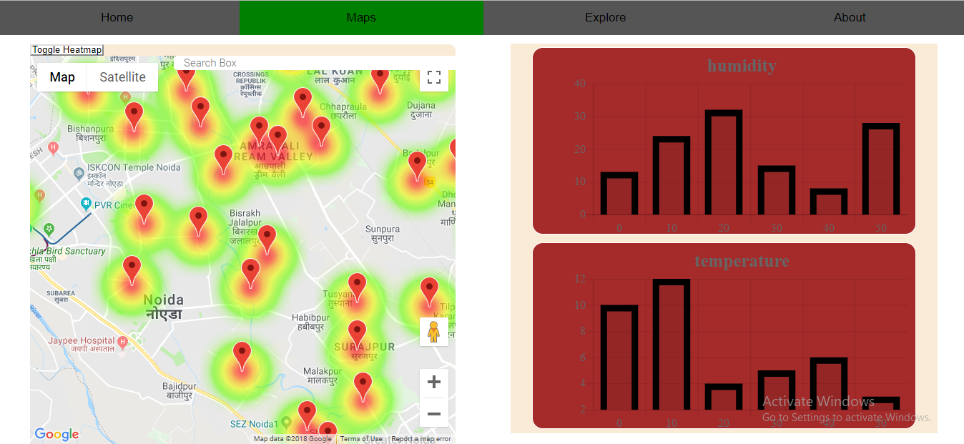

Also there is an explore menu with an outstanding UI/UX which is responsive to weather changing every 15 seconds as it changes the background image according to the latest development

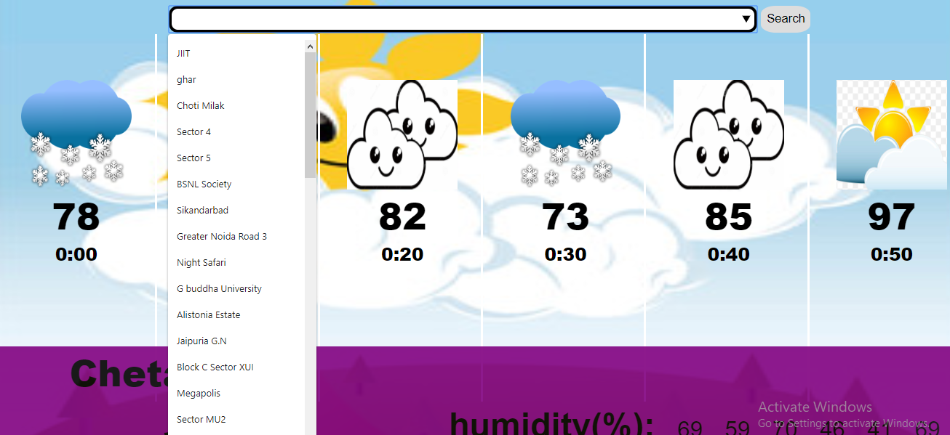

The backend of project is made on Express framework of Node.js while the front end is pure HTML5 and CSS3 but there for charts of temperature and humidity I have used barcharts and line charts functions of CHART.js.

Also for Visualisation methods there is Google Maps Javascript API and Heat map api also from Google Maps.

The temperature of various places in the city of Noida shown are random numbers between 70 and 110 degree fahrenheit are just random integers generated by function Math.random, while the places and their names are real, the numbers are just fake.That is to show the potential of this app to in creating a HeatMap.

Further Advancement:-

A low cost mobile weather station made in Sri Lanka can capture and transmit near real-time data on rainfall. It raises alarm in the event of extreme rainfall and other natural disasters, which can help farmers, disaster management officials and the scientists plan ahead

The latest New Mobile Weather Stations, as they are called are equipped with an atomic clock to give precise time and date readings, and a GPS sensor, which updates automatically if they are moved.

Chemin is developing a system for connecting such low-cost portable weather stations to Sri Lanka's mobile phone network and transfer the data.  He plans to send SMS alerts from these devices directly to farmers and government officials when rainfall levels are expected to rise in a specific area and help them plan for the worst.

It would give the tank and reservoir managers advance warning to prepare for higher-than-usual flows of water into the tank system, so that they could react and release water elsewhere along the network to that the system doesn’t become overwhelmed and flood.

What I am trying to say here is that with new development we will not just be able to see the current status but with the help of accurate data accumulated over a large period of individual locations we can predict change in rainfalls, droughts , wind speed and numerous other areas.

Marketing Status And Vision

What I propose to do here is using real time gps tracking system and a rainfall sensor to which accumulated over large variety can really eliminate the need of large costly satellites and news channels for day to day use.

This equipment and can be bought and sold at a very low price and even better its small size ensures easily integration and installation within large equipments.

With proper funding and a creative and hardworking team behind this We can finally have a weather station which is available to all, cheap and quite frankly trusted by all as this can be home-tested as well.

Conclusion

In this report, we have shown the hardware and software design of an automated weather station which, besides offering wireless communication and energy autonomy, provides not only an accumulated data of various locations with the intensity of temperature, it also gives a safe route and a sense of knowledge.

An accurate comparison of the prediction results with other approaches is difficult because the data, as well as the prediction interval, are not the same and, typically, a prediction horizon of just one step is considered in these approaches.

If any of the approaches referenced above would be applied for a specific site, a weather station would have to be installed in that location, models would have to be designed externally, using data that should be transmitted in real-time from that weather station, and one-step-ahead predictions would have to be computed, in real-time, externally. The automated weather station proposed in this work is a complete and autonomous solution to this problem, besides enabling to have excellent quality predictions over a user-defined prediction horizon, and not for a single step. As such, we anticipate that a commercial version of such a device will have a large range of practical applications, examples being in PV plants, energy building management systems as well as in agricultural applications.

References

[Marco Ruggeri](https://www.hackster.io/marco-ruggeri), “WiFi weather station with sending data on line and graphical rendering of them.”,

Available:-<https://www.hackster.io/marco-ruggeri/wifi-weather-stations-with-online-graphs-e7a061>

Indestructables.com

[Integrated Wireless Propagation Models by William C. Y. Lee](https://www.amazon.in/Integrated-Wireless-Propagation-Models-William-ebook/dp/B00LI364WG/ref=sr_1_1?ie=UTF8&qid=1538591975&sr=8-1&keywords=WiFi+weather+station+books)